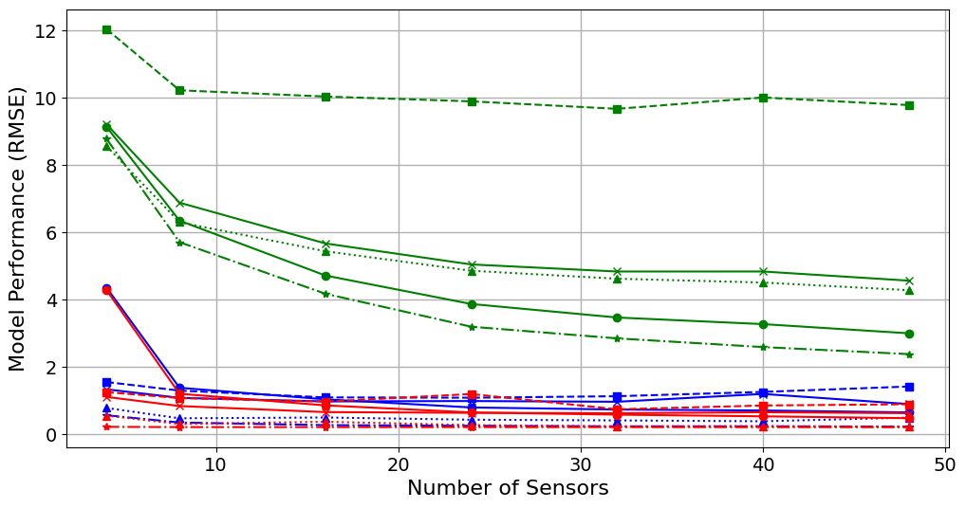

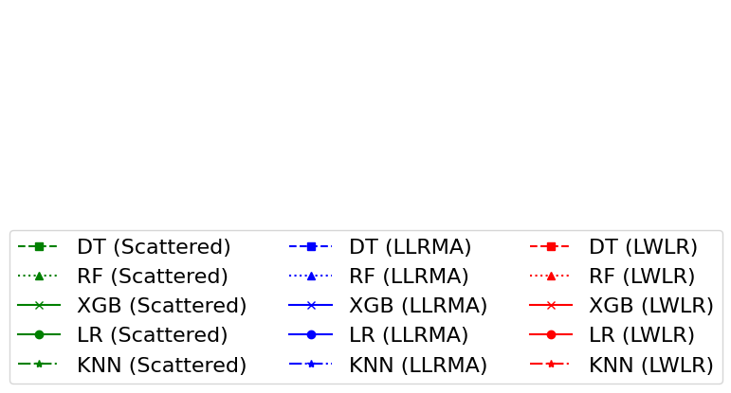

**Figure:** UWB Model Performance on Sensor topology C for Different Sensor Configurations

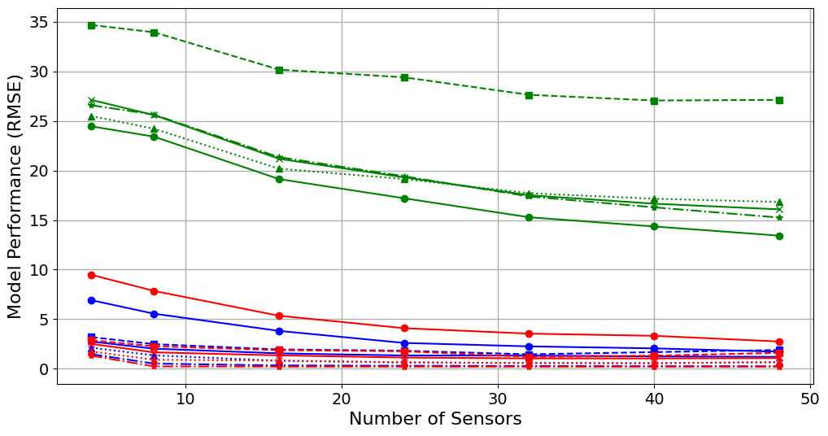



**Figure:** MICS Model Performance on Sensor topology C for Different Sensor Configurations

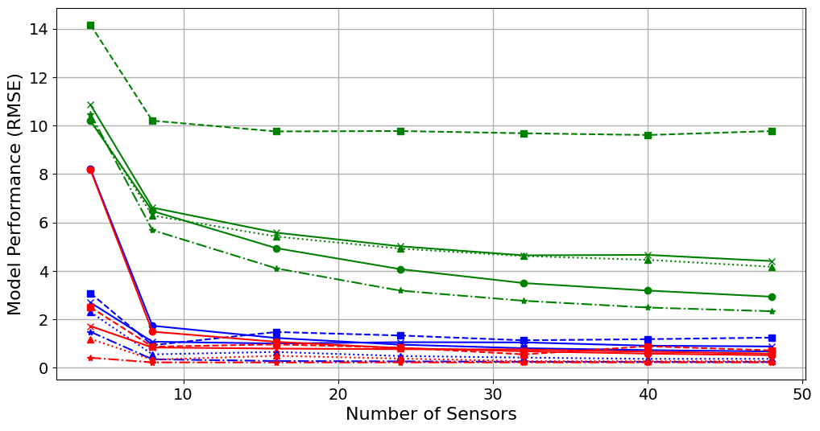



**Figure:** UWB Model Performance on Sensor topology F for Different Sensor Configurations

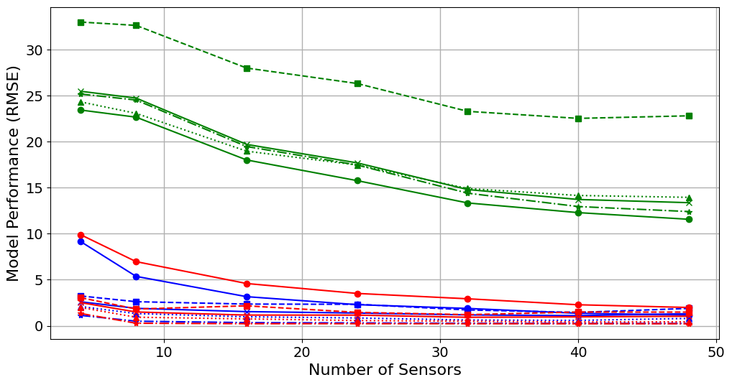



**Figure:** MICS Model Performance on Sensor topology F for Different Sensor Configurations